**Github repo url:**

<https://github.com/Sinolinaa/devops-build/>

**Deployed site url:**

<http://13.234.186.94/>

**Docker image name:**

Sinolinaa/dev : latest

Sinolinaa/prod: latest

**Submission:**

Jenkins (login page, configuration settings, execute step commands)

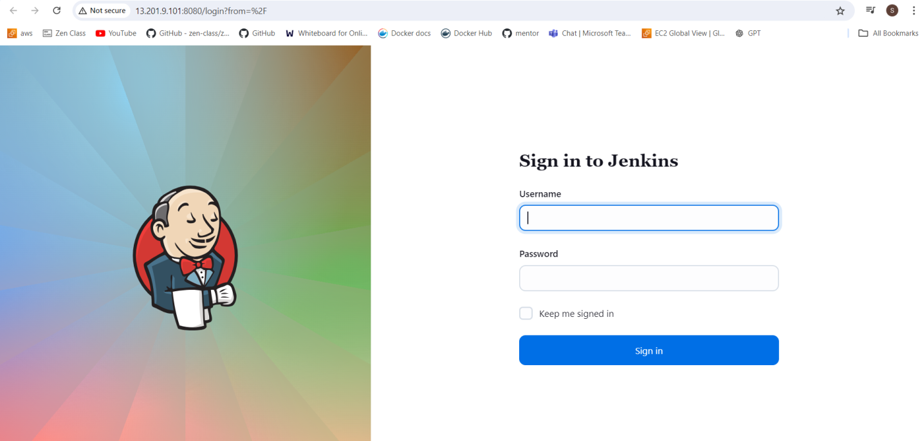

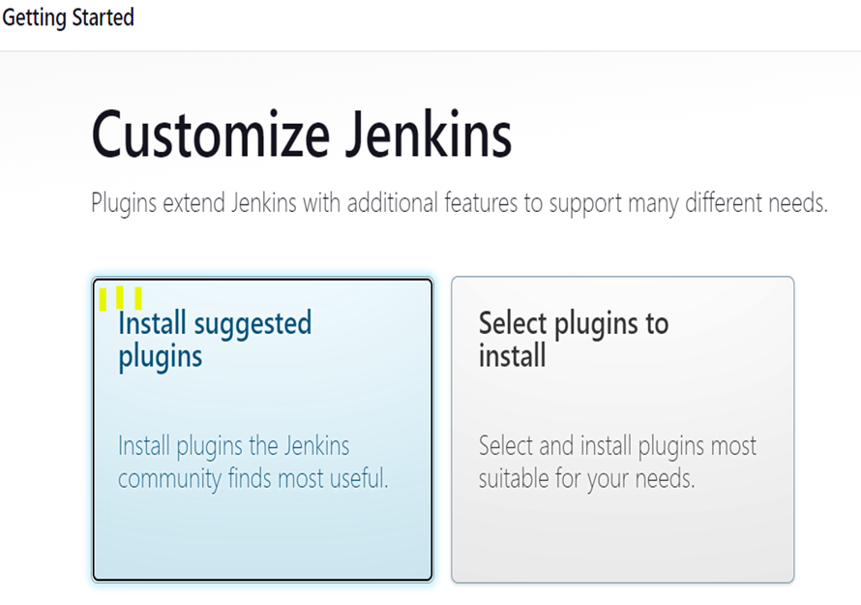

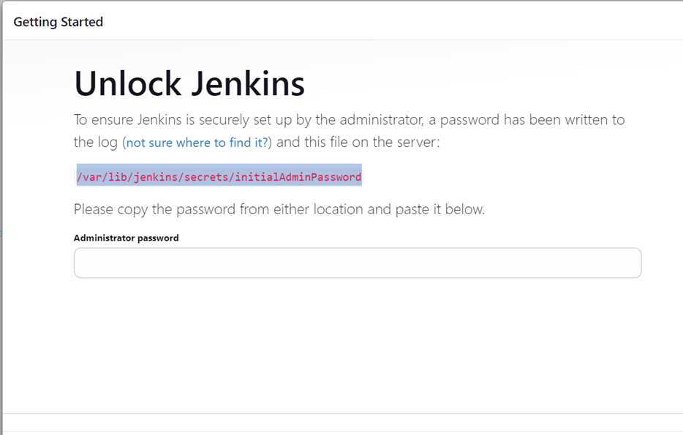

AWS (EC2-Console, SG configs)

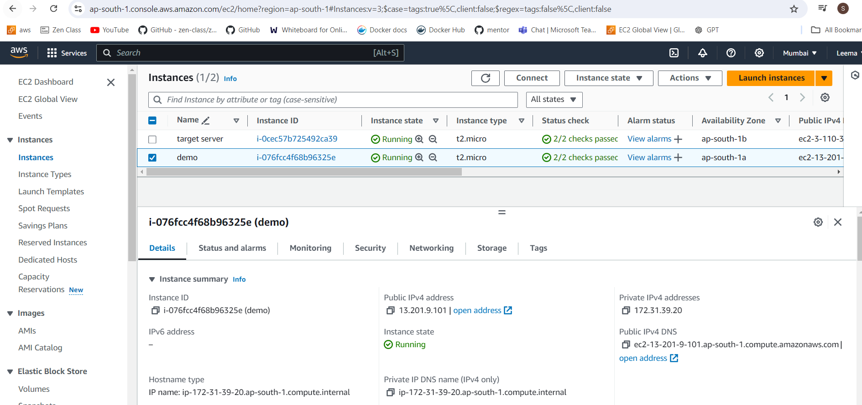

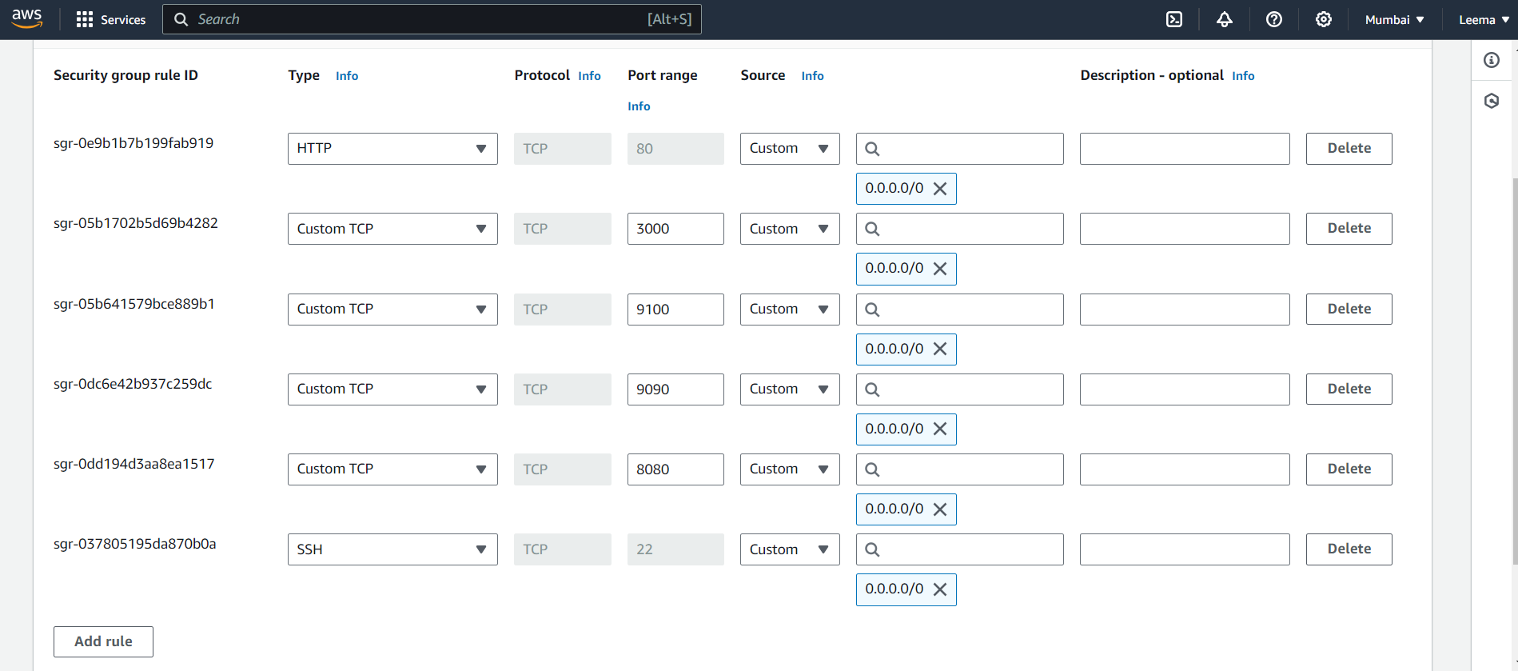

Docker hub repo with image tags

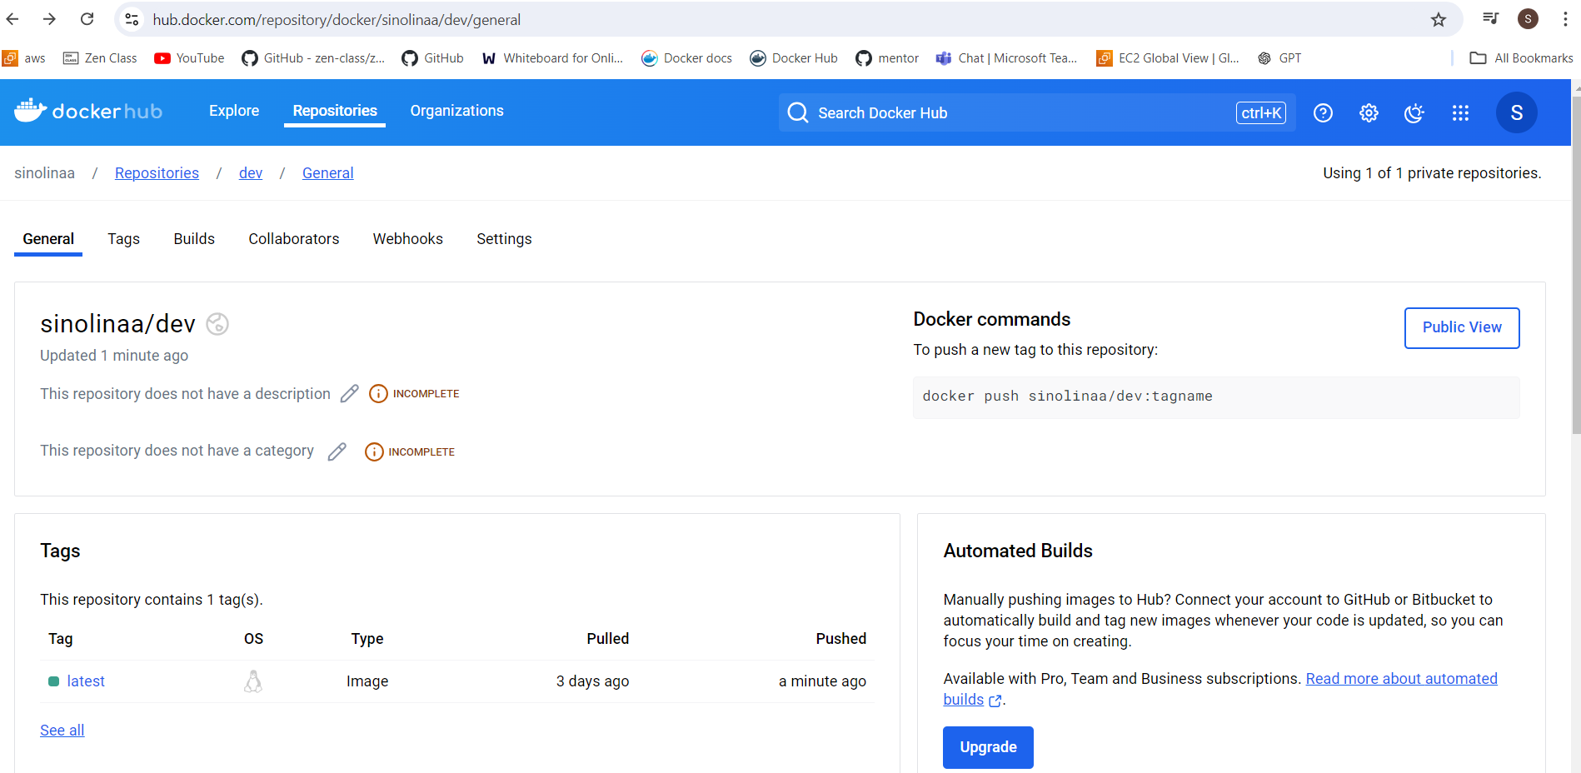

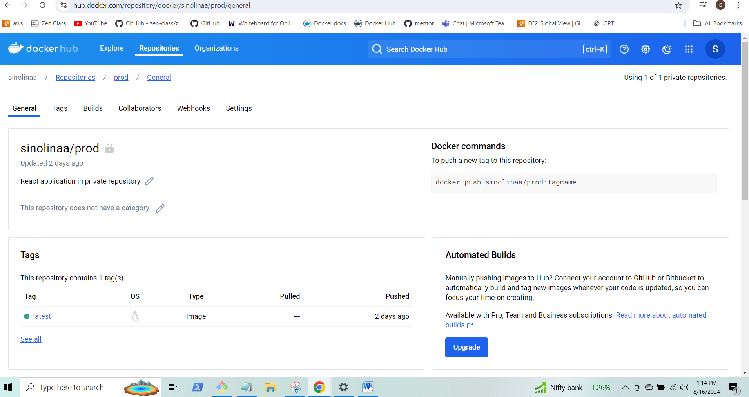

Deployed site page

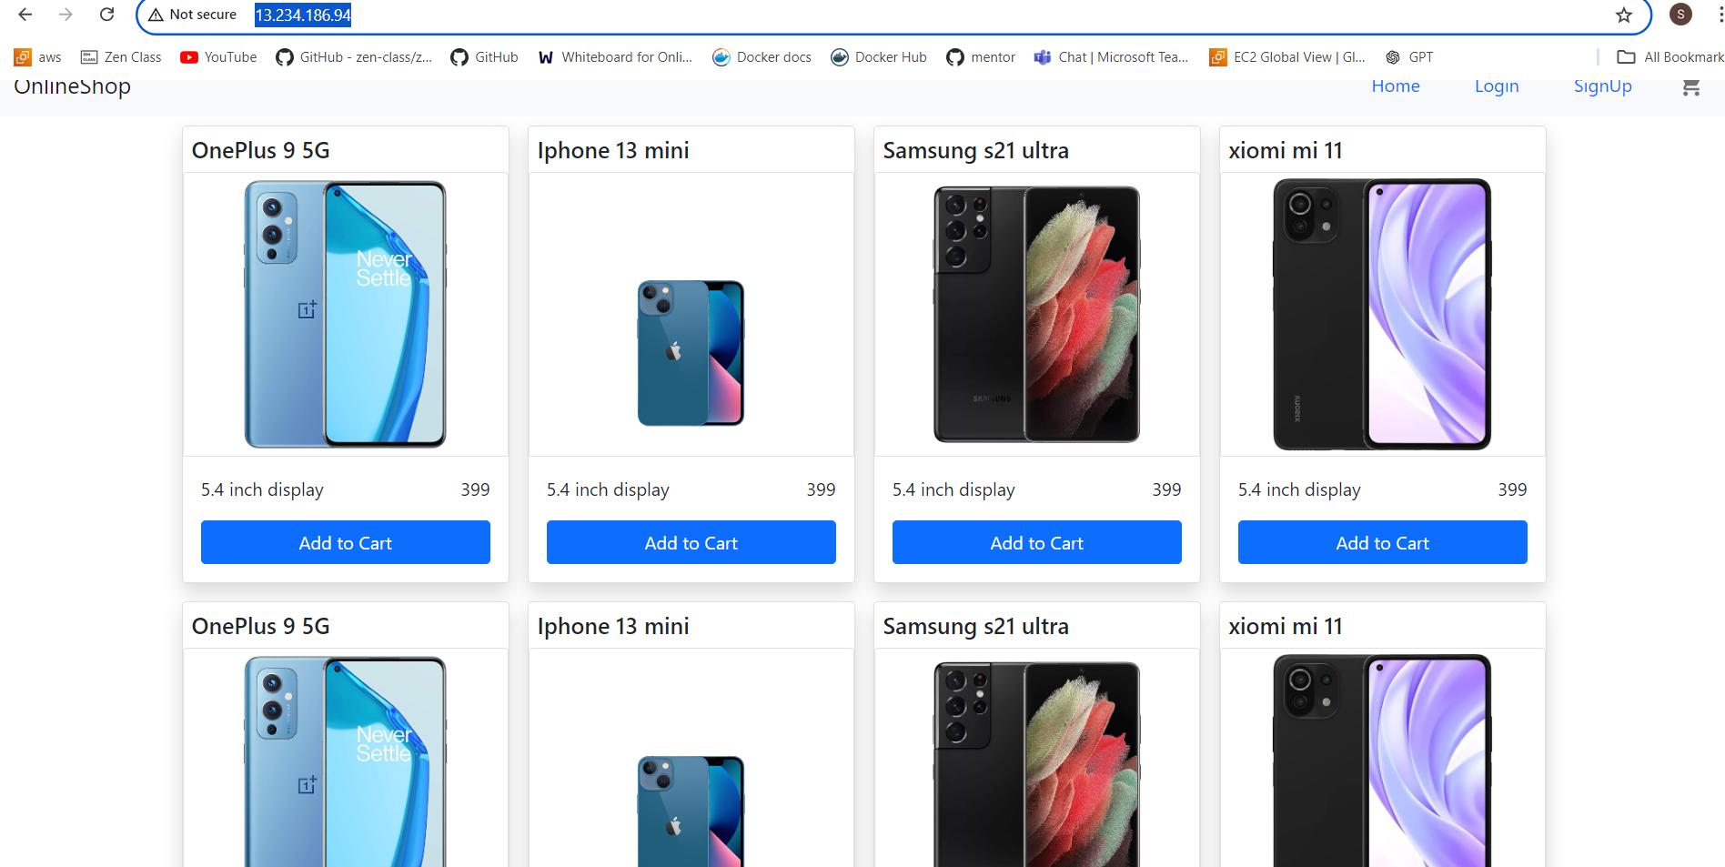

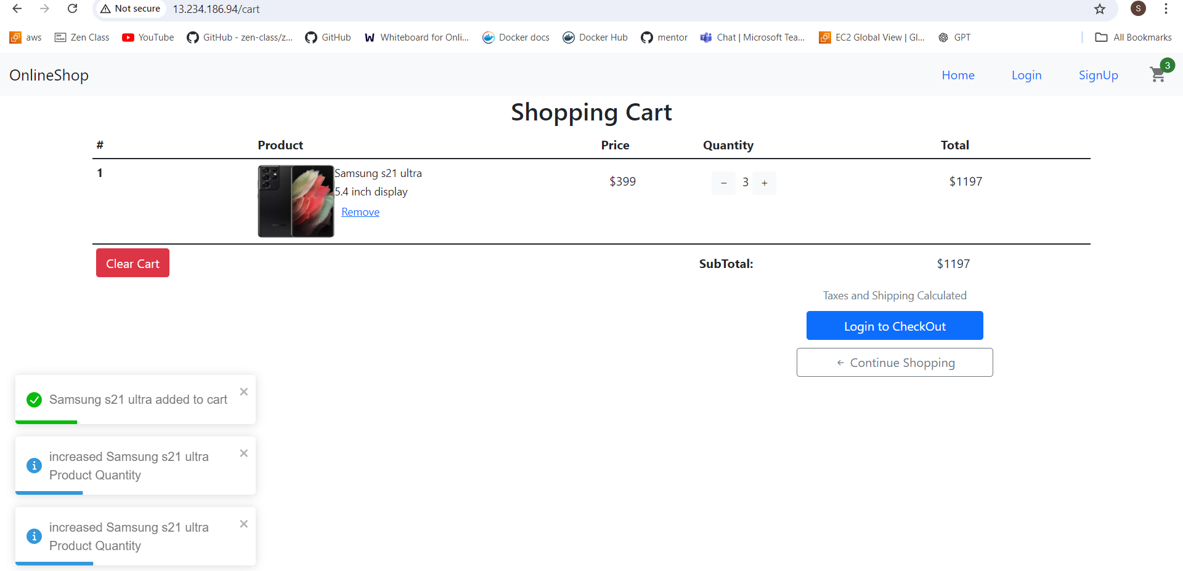

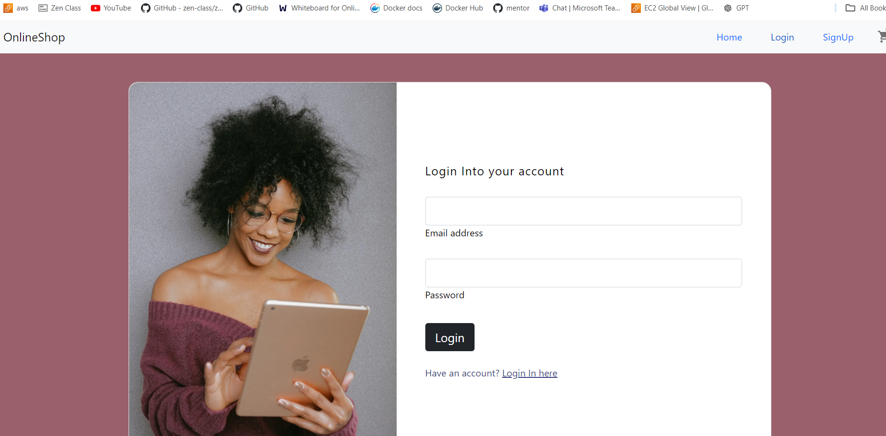

Monitoring health check

